**Day 2.0**

**Unique visits counter using OOP PHP**

The needed work is creating a counter that count unique visits of a certain web page , which only means that if the same user refreshes the web page using the same browser it will be counted only as 1 visit but if he visited the same page using 2 browsers it will be counted as 2 visits not one .

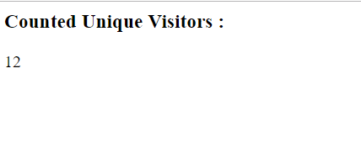

*That’s all what the screen should print*

Hints for the Solution:

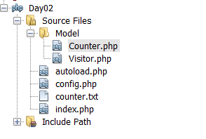

1. The file Structure of the solution:

* The Model: A folder in which all classes should be stored, you will need TWO classes a counter and a Visitor class
* An Autoload file to autoload the classes when they are needed and the config file
* Config file that include settings such as the path of the file in which the visits count will be stored
* Counter.txt : the text file which you will use to save the visited count
* Index file, the main file which will handle the requests by requiring the autload, then call the classes in the Model (the business logic) then send the response to the user with the UI shown above .

1. Why you need the session for in this example ?

To mark visits in the same browser so they are not recounted so if a user comes with a flag like “is_counted” = true in his session he wont be recounted unlike a user without this flag in his session.

1. Why you need a file for in this example?

To save the overall count of all visits to read it and increment it .

Remember :

1. At any class don’t forget to use the “$this->” when calling the member variables and methods of this class , this is one of the issues that NetBeans does not highlight yet it turn out to be a source of many erors
2. Session are like shopping cart for each user so if you store something in session for one user it doesn’t mean that is for all users so it’s an excellent way to differentiate between users (in our example who is counted and who is not) .